Literature Search Protocol
(Product name)

Prepared by: | Name, Surname, Title | Signature
Author:

Reviewer:

Approval:

Evaluator:

Record ID:
medical device:
Product Description:

Contents
1. Scope of literature search 3
2. Methods 3
3. Literature Selection Plan 4
4. Appraisal Value 5
5. Level of Clinical Evidence 6
6. Biases and Limitations 7
7. Literature Search Results 8
8. List of Appraised Articles and Reports 10
9. Document History 13

Scope of literature search
The Scope of this Literature Search is identifying published clinical data and scientific literature that may assist to evaluate the performance and safety of <Company Name> medical devices, in accordance with Medical Device Regulation - Regulation (EU) 2017/745 of the European Parliament and of the Council of 5 April 2017.

Methods
Name/Roles of Person(s) Undertaking the Literature Search | Add text
Period Covered by Search | Add text  e.g. 2014.-2024.
Literature Sources Used to Identify Data
Scientific Databases | PubMed (including PubMed Central), Cochrane
Adverse Event Report Databases | MAUDE, US FDA TPLC database
Manual Searching of Literature | Add time frame of search  e.g. 2014.-2024.Google search
Database Search Details
Search Strategy | PubMed & Cochrane:  PubMed Central & Cochrane:  Manual Search: add term  Maude: add equivalent  TPLC US FDA Database: add searched term
Selection Criteria Used to Choose Articles | Relevance and connection of published clinical data to intended use, design characteristics, safety and performance of the medical device under evaluation.

Literature Selection Plan
The search and selection process for the literature review was derived from the PRISMA statement for the transparent reporting of systematic reviews.
A summary of the results of the Literature Search is illustrated in the following figure.
An adequate flow diagram should be chosen, depending on the type of the device and search type, and whether it is a legacy device, a new device on the market, an update of Clinical evaluation, or a new one. All four flow diagrams are on the following link http://www.prisma-statement.org/PRISMAStatement/FlowDiagram
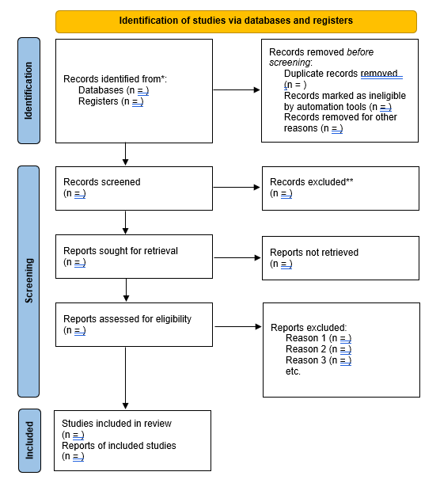
Brief explanation related to final number of articles.

Appraisal Value
An additional appraisal is conducted using a scoring of the identified articles. The score was determined against the following suitability and contribution criteria:
Table: Appraisal Criteria - Appraisal Value ≥ 75
Suitability Criteria | Description | Appraisal System
Appropriate device | Was the data generated from the device in question? | D1 Actual device  D2 Comparable  device  D3 Other device | 100  50  0
Appropriate device application | Was the device used for the same intended use (e.g., methods of deployment, application, etc.)? | A1 Same use  A2 Minor deviation  A3 Major deviation | 100  50  0
Appropriate patient group | Were the data generated from a patient group that is representative of the intended treatment population (e.g., age, sex, etc.) and clinical condition (e.g., disease, including state and severity)? | P1 Applicable  P2 Limited  P3 Different  population | 100  50  0
Acceptable data or report collation | Do the reports or collations of data contain sufficient information to be able to undertake a rational and objective assessment? | R1 High quality  R2 Minor deviation  R3 Insufficient  information | 100  50  0
For example, in our appraisal process
NOTE: If Appraisal criteria is marked as N/A (Not Applicable), the result should be divided by the number of remaining Appraisal criteria.

Level of Clinical Evidence
In addition, the studies were classified according to levels of evidence. The included studies were peer-reviewed articles of the highest quality of evidence retrieved on the relevant performance and safety concerns related to the use of Device name or other add type of device which is under evaluation.
The quality of evidence considers systematic review and meta-analyses as well as clinical studies ahead of case studies or observational outcome studies covering the same topic. Consequently, case reports and general reviews were only considered if no other articles of higher quality of evidence were identified.
The following table was used to determine the level of evidence of the articles reviewed in full
Table 1: Level of Evidence of included literature
Level | Type of evidence
I | High quality prospective cohort study with adequate power or systematic review of these studies
II | Lesser quality prospective cohort, retrospective cohort study, untreated controls from an RCT, or systematic review of these studies
III | Case-control study or systematic review of these studies and reviews
IV | Case series
V | Expert opinion; case report or clinical example; or evidence based on physiology, bench research or “first principles”

Biases and Limitations
Add explanation regarding literature search- who took search, which base was used, which string, which period of time… The same explanation is needed for safety records
The literature search for Device name was performed by two members of the clinical evaluation team (see Clinical Evaluation Report for Device name) and took into consideration the most current systematic reviews of clinical applications and clinical investigations conducted on (add product type) devices. The higher levels of types of evidence were considered ahead of lower levels of evidence when available.
To limit bias, the same search string was used during the search of two databases for relevant study articles for the clinical evaluation of Device name: PubMed (including PubMed Central for one search string (add number of strings) and Cochrane database. The search strategy was limited to humans (no age limits indicated), and to studies published between 20XX-202X.
Manual search retrieved additional review articles for clinical guidelines and current public health concerns on add condition/ disease treated by device.
Safety records were retrieved only from the US FDA database. The US FDA MAUDE database retrieved no search results for the identified similar devices, thus the US FDA database for Medical Device Reporting (MDR) was searched for related device problems. No other medical device databases were searched.

Literature Search Results
The complete list of search strings and initial hits are detailed in the following Tables for the database searches conducted in PubMed and Cochrane.
The full list of included articles is provided in the are provided in Table 5 - after screening and appraisal according to the PRISMA guidelines and qualification of evidence.

Table 2: Key word search results from PUBMED database and initial number of hits prior to screening and appraisal
Query No | Database | Query string | Initial Hits | Hits Query
e.g. P-01 (query word) | PubMed |  |  | Add date
 | PubMed
 | PubMed
 | PubMed
Table 3: Key word search results from COCHRANE database and initial number of hits prior to screening and appraisal
Query No | Database | Query string | Initial Hits | Hits Query
e.g. P-01 (query word) | COCHRANE |  |  | Add date
 | COCHRANE
 | COCHRANE
 | COCHRANE

Table 4: Search results in other databases
Search entry | Database | Description | Results | Search Date
Add search entry | Google | Manual search | Add | Add date
Add search entry | MAUDE | US FDA MAUDE database | Add | Add date
Add search entry | TPLC | Total Product Life Cycle – US FDA summary of medical device reports and patient problems from 20XX-202X. | Add | Add date
Add search entry | … |  | Add | Add date

List of Appraised Articles and Reports
Table 5: List of Included articles from Systematic Search and Appraisal values
CER reference No. | Article | Appraisal | Value | Level of Evidence
Add Number of article/study | Cite | D2, A2, P1, R1 | 75 | I
Add Number of article/study | … | D1, A2, P1, R1 | 87.5 | II
Add Number of article/study | … | … | … | …
Add Number of article/study | … | … | … | …
Table 6: List of Manually included articles and appraisal values
CER reference No. | Article | Appraisal | Value | Level of Evidence
Add Number of article/study | Cite | D3, A1, P1, R1 | 75 | I
Add Number of article/study | … | D1, A2, P1, R1 | 87.5 | II
Add Number of article/study | … | … | n/a | n/a
Add Number of article/study | … | … | … | …
Table 7: List of Excluded articles based on full-text review- with justification
Title | Author | Exclusion Justification
 |  | e.g. Out of scope
 |  | e.g. Lower quality of evidence
Table 8: Summary of 10 most common Patient Problems for Add device in the FDA Database between 201X.- 202X.
Patient Problem | MDRs with this Patient Problem
Add  e.g. No Known Impact Or Consequence To Patient | Add number of reports found
e.g. No Information | Add number of reports found
e.g. Pain | Add number of reports found
… | Add number of reports found
… | Add number of reports found
… | Add number of reports found
… | Add number of reports found
… | Add number of reports found
… | Add number of reports found
… | Add number of reports found
Table 9: Summary of 10 most common MDRs for Add device in the FDA Database between 201X.- 202X.
Device/ Product Problem | Number of MDRs with this Device/Product problem
Add  e.g. Incorrect Measurement | Add number of reports found
e.g Overheating of Device | Add number of reports found
e.g Mechanical Problem | Add number of reports found
e.g Break | Add number of reports found
… | Add number of reports found
… | Add number of reports found
 | Add number of reports found
 | Add number of reports found
 | Add number of reports found
 | Add number of reports found

If needed, depending on the device/product, more tables should be added with MAUDE data. For example, if the device/product has accessories, MDRs for those should be considered as well, from the technical failure side and their impact on the patient/user.

Document History
Version | Author | Description of Changes
01 | Add | First version of LSP created

Burns PB, Rohrich RJ, Chung KC. The levels of evidence and their role in evidence-based medicine. Plast Reconstr Surg. 2011 Jul;128(1):305-310. doi: 10.1097/PRS.0b013e318219c171. PMID: 21701348; PMCID: PMC3124652. https://www.ncbi.nlm.nih.gov/pmc/articles/PMC3124652/

